**Q12. Create an extended ACL to block specific applications, such as HTTP or FTP traffic. Test the ACL rules by attempting to access blocked services.**

**Configuring the router :**

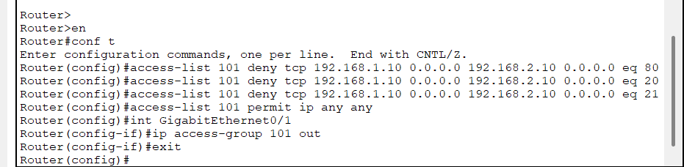

**Verification:**

**HTTP request:**

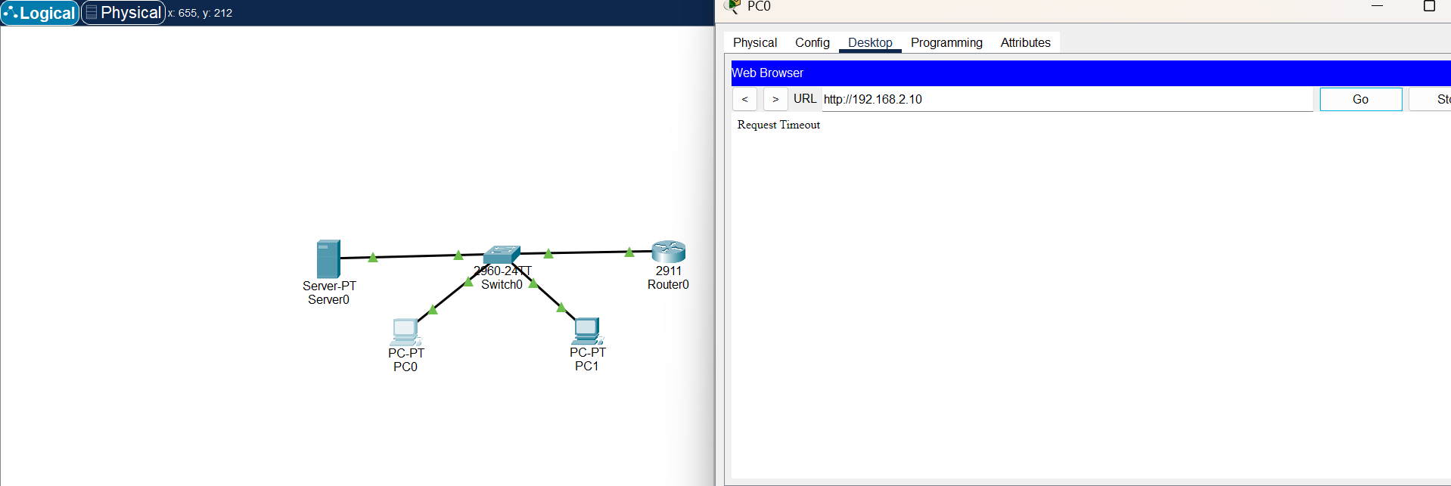

**ftp request:**

